Working Together in Research Application Form

Please ensure you have read the accompanying Guidance Notes before completing this form and contact [grants@sycf.org.uk](mailto:grants@sycf.org.uk) with any questions.

Section 1: Organisation

|  |  |  |
| --- | --- | --- |
| Organisation name |  | |
| Organisation address including postcode |  | |
| Contact name and role |  | |
| Contact telephone number |  | |
| Contact email address |  | |
| Organisation Website |  | |
| Organisation Start Date (Month/Year) |  | |
| Type of Organisation:  Registered Charity  Company Limited by guarantee  Unincorporated club or association  Community Interest Company  Charitable Incorporated Organisation  Other | Please select: | Organisation Number (if applicable) |
|  |  |
|  |  |
|  |  |
|  |  |
|  |  |
|  |  |
| How many paid staff are involved in your organisation? |  | |
| How many volunteers, including a management committee, are involved in your organisation? |  | |
| Organisation Turnover (income in your last financial year) |  | |

Section 2: Project Details

|  |  |
| --- | --- |
| Project Start Date |  |
| Project End Date |  |
| Local authority your project will take place in |  |
| Number of beneficiaries that you aim to directly engage with and benefit from your project |  |
| Please give us a brief description of your organisation |  |
| Have you previously engaged with any aspect of the Working Together in Research project since its start in October 2023?  If yes, please give details. |  |
| Have you taken part in research projects before? If yes, please give brief details. If not, please tell us why |  |
| Please tell us about your idea for a partnered research project. What specific health inequality in your community you would like to focus on? |  |
| What benefits would a partnered research project bring to both your organisation and the communities you work in? |  |
| How do you think a partnered research project would help your organisation and community after the end of this programme? |  |

Section 3: Project Budget

Please tell us about the costs of this project and include a breakdown of expenditure so we can see how you will use any grant given to you.

|  |  |
| --- | --- |
| Staff Costs | £ |
| Volunteer Costs | £ |
| Overheads (rent, utilities, etc) | £ |
| Marketing and Publicity Costs | £ |
| Resources | £ |
| Other | £ |

Section 4: Supporting Documents

If you have never applied to SYCF before or your application was more than 3 years ago, please provide:

* A reference (by someone who knows you but does not work for you)
* Your governing document and/or constitution
* A list of your current Trustees/Management Committee if it is not included in your governing document or constitution.
* A copy of your organisation bank statement
* A recent set of accounts (income/expenditure) if they are not available for us to see on Charities Commission or Companies House

Please read and date the declaration statement below:

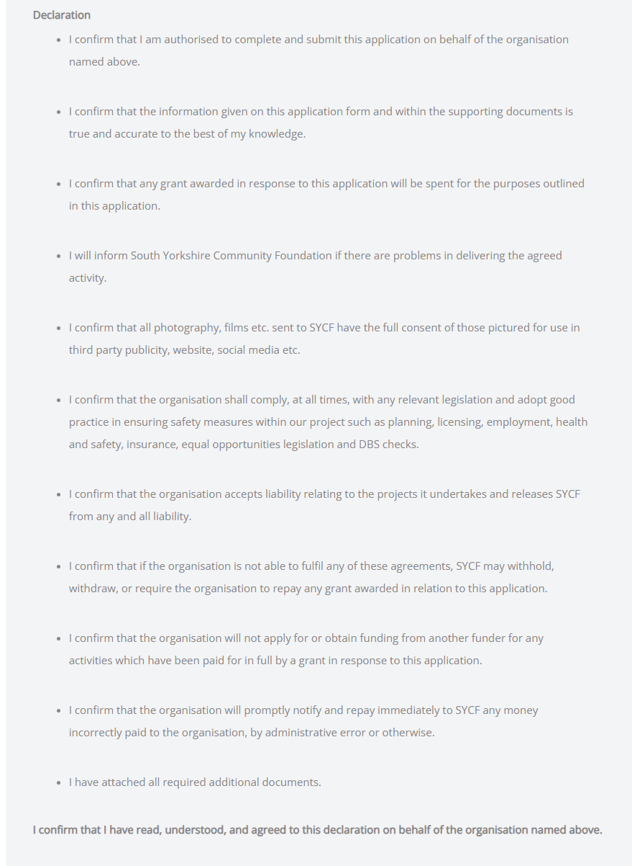

Name

Date